# ***What is Heart Disease?***

Heart disease describes a range of conditions that affect your heart. Diseases under the heart disease umbrella include blood vessel diseases, such as coronary artery disease; heart rhythm problems (arrhythmias); and heart defects you're born with (congenital heart defects), among others. The term "heart disease" is often used interchangeably with the term "cardiovascular disease." Cardiovascular disease generally refers to conditions that involve narrowed or blocked blood vessels that can lead to a heart attack, chest pain (angina) or stroke. Other heart conditions, such as those that affect your heart's muscle, valves or rhythm, also are considered forms of heart disease. Heart failure is a serious condition with high prevalence (about2% in the adult population in developed countries, and or than8%inpatients olderthan75years). About 3 – 5%ofhospitaladmissions are linked with heart failure incidents. Heart failure is the first cause of admission by healthcare professionals in their clinical practice. The costs are very high, reaching up to 2% of the total health costs in the developed countries. Building an effective disease management strategy requires analysis of large amount of data, early detection of the disease, assessment of the severity and early prediction of adverse events. This will inhibit the progression of the disease, will improve the quality of life of the patients and will reduce the associated medical costs. Toward this direction machine learning techniques have been employed. The aim of this paper is to present the state-of-the-art of the machine learning methodologies applied for the assessment of heart failure. More specifically, models predicting the presence, estimating the subtype, assessing the severity of heart failure and predicting the presence of adverse events, such as destabilizations, re-hospitalizations, and mortality are presented. According to the authors' knowledge, it is the first time that such a comprehensive review, focusing on all aspects of the management of heart failure, is presented.

***How the Heart Works?***

•

•



Figure 1 Working of the Heart

***Chambers and valves of the heart***

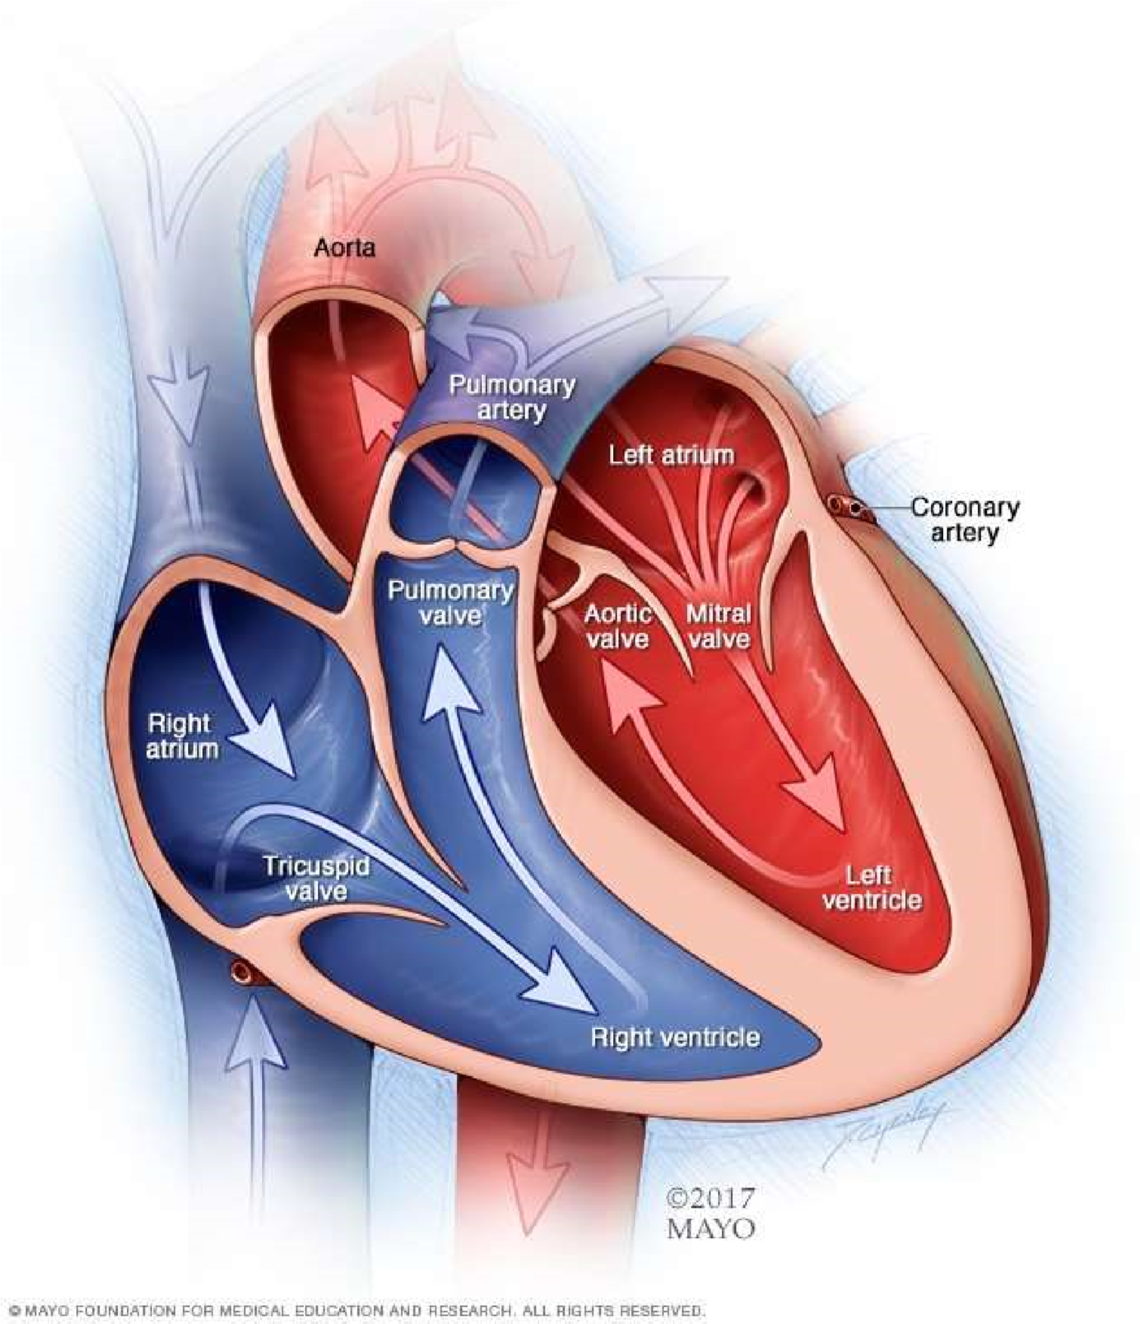

Your heart is a pump. It's a muscular organ about the size of your fist, situated slightly left of center in your chest. Your heart is divided into the right and the left side. The division prevents oxygen-rich blood from mixing with oxygen-poor blood. Oxygen-poor blood returns to the heart after circulating through your body.

The right side of the heart, comprising the right atrium and ventricle, collects and pumps blood to the lungs through the pulmonary arteries.

* The lungs refresh the blood with a new supply of oxygen. The lungs also breathe out carbon dioxide, a waste product.
* Oxygen-rich blood then enters the left side of the heart, comprising the left atrium and ventricle.
* The left side of the heart pumps blood through the aorta to supply tissues throughout the body with oxygen and nutrients.

***Heart valves***

Four valves within your heart keep your blood moving the right way by opening only one way and only when they need to. To function properly, the valve must be formed properly, must open all the way and must close tightly so there's no leakage. The four valves are:

* Tricuspid
* Mitral
* Pulmonary
* Aorti

***Causes of cardiovascular disease***

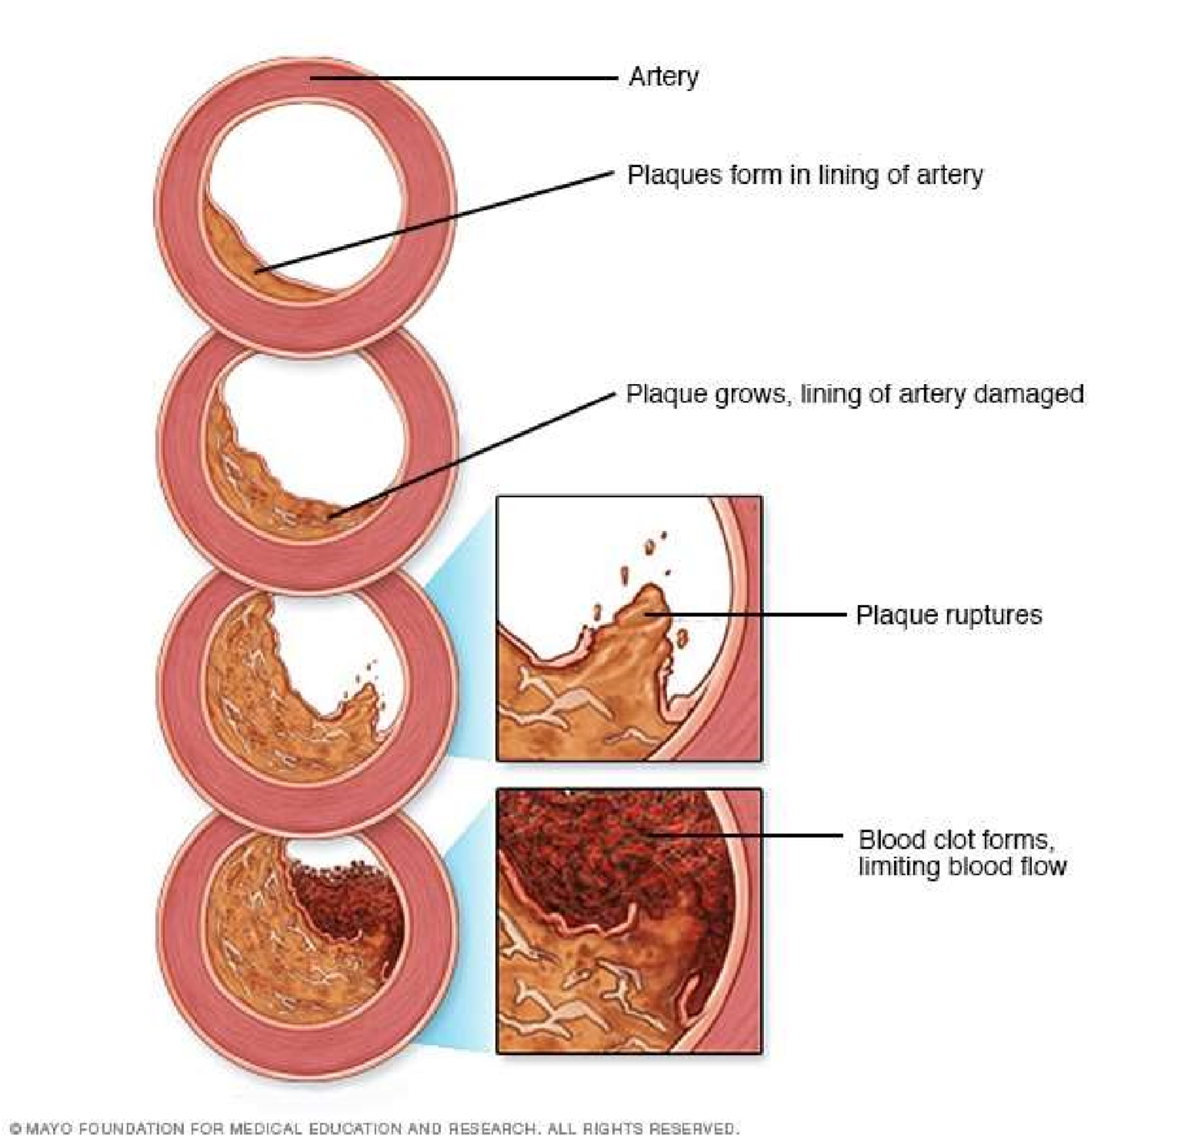

Figure 2 Causes of Cardiovascular Diseases

Development of atherosclerosis - While cardiovascular disease can refer to different heart or blood vessel problems, the term is often used to mean damage to your heart or blood vessels by atherosclerosis (ath-ur-o-skluh-ROE-sis), a buildup of fatty plaques in your arteries. Plaque buildup thickens and stiffens artery walls, which can inhibit blood flow through your arteries to your organs and tissues. Atherosclerosis is also the most common cause of cardiovascular disease. It can be caused by correctable problems, such as an unhealthy diet, lack of exercise, being overweight and smoking.

Causes of heart arrhythmia - Common causes of abnormal heart rhythms (arrhythmias) or conditions that can lead to arrhythmias include:

Heart defects you're born with (congenital heart defects)

* Coronary artery disease
* High blood pressure
* Diabetes
* Smoking
* Excessive use of alcohol or caffeine
* Drug abuse
* Stress
* Some over-the-counter medications, prescription medications, dietary supplements and herbal remedies
* Valvular heart disease

In a healthy person with a normal, healthy heart, it's unlikely for a fatal arrhythmia to develop without some outside trigger, such as an electrical shock or the use of illegal drugs. That's primarily because a healthy person's heart is free from any abnormal conditions that cause an arrhythmia, such as an area of scarred tissue. However, in a heart that's diseased or deformed, the heart's electrical impulses may not properly start or travel through the heart, making arrhythmias more likely to develop.

Causes of congenital heart defects - Congenital heart defects usually develop while a baby is in the womb. Heart defects can develop as the heart develops, about a month after conception, changing the flow of blood in the heart. Some medical conditions, medications and genes may play a role in causing heart defects. Heart defects can also develop in adults. As you age, your heart's structure can change, causing a heart defect.

Causes of cardiomyopathy - The cause of cardiomyopathy, a thickening or enlarging of the heart muscle, may depend on the type:

* Dilated cardiomyopathy. The cause of this most common type of cardiomyopathy often is unknown. It may be caused by reduced blood flow to the heart (ischemic heart disease) resulting from damage after a heart attack, infections, toxins and certain drugs. It may also be inherited from a parent. It usually enlarges (dilates) the left ventricle.
* Hypertrophic cardiomyopathy. This type, in which the heart muscle becomes abnormally thick, usually is inherited. It can also develop over time because of high blood pressure or aging.
* Restrictive cardiomyopathy. This least common type of cardiomyopathy, which causes the heart muscle to become rigid and less elastic, can occur for no known reason. Or it may be caused by diseases, such as connective tissue disorders, excessive iron buildup in your body (hemochromatosis), the buildup of abnormal proteins (amyloidosis) or by some cancer treatments.

Causes of heart infection - A heart infection, such as endocarditis, is caused when an irritant, such as a bacterium, virus or chemical, reaches your heart muscle. The most common causes of heart infection include:

* Bacteria
* Viruses
* Parasites

Causes of valvular heart disease - There are many causes of diseases of your heart valves.

You may be born with valvular disease, or the valves may be damaged by conditions such as:

* Rheumatic fever
* Infections (infectious endocarditis)
* Connective tissue disorders

***Risk factors***

Risk factors for developing heart disease include

* Age. Aging increases your risk of damaged and narrowed arteries and weakened or thickened heart muscle.
* Sex. Men are generally at greater risk of heart disease. However, women's risk increases after menopause.
* Family history. A family history of heart disease increases your risk of coronary artery disease, especially if a parent developed it at an early age (before age 55 for a male relative, such as your brother or father, and 65 for a female relative, such as your mother or sister).
* Smoking. Nicotine constricts your blood vessels, and carbon monoxide can damage their inner lining, making them more susceptible to atherosclerosis. Heart attacks are more common in smokers than in nonsmokers.
* Certain chemotherapy drugs and radiation therapy for cancer. Some chemotherapy drugs and radiation therapies may increase the risk of cardiovascular disease.
* Poor diet. A diet that's high in fat, salt, sugar and cholesterol can contribute to the development of heart disease.

High blood pressure. Uncontrolled high blood pressure can result in hardening and thickening of your arteries, narrowing the vessels through which blood flows.

* High blood cholesterol levels. High levels of cholesterol in your blood can increase the risk of formation of plaques and atherosclerosis.
* Diabetes. Diabetes increases your risk of heart disease. Both conditions share similar risk factors, such as obesity and high blood pressure.
* Obesity. Excess weight typically worsens other risk factors.
* Physical inactivity. Lack of exercise also is associated with many forms of heart disease and some of its other risk factors, as well.
* Stress. Unrelieved stress may damage your arteries and worsen other risk factors for heart disease.
* Poor hygiene. Not regularly washing your hands and not establishing other habits that can help prevent viral or bacterial infections can put you at risk of heart infections, especially if you already have an underlying heart condition. Poor dental health also may contribute to heart disease.

***Complications***

Complications of heart disease include:

* Heart failure. One of the most common complications of heart disease, heart failure occurs when your heart can't pump enough blood to meet your body's needs. Heart failure can result from many forms of heart disease, including heart defects, cardiovascular disease, valvular heart disease, heart infections or cardiomyopathy.
* Heart attack. A blood clot blocking the blood flow through a blood vessel that feeds the heart causes a heart attack, possibly damaging or destroying a part of the heart muscle. Atherosclerosis can cause a heart attack.
* Stroke. The risk factors that lead to cardiovascular disease also can lead to an ischemic stroke, which happens when the arteries to your brain are narrowed or blocked so that too little blood reaches your brain. A stroke is a medical emergency — brain tissue begins to die within just a few minutes of a stroke.
* Aneurysm. A serious complication that can occur anywhere in your body, an aneurysm is a bulge in the wall of your artery. If an aneurysm bursts, you may face life-threatening internal bleeding.
* Peripheral artery disease. Atherosclerosis also can lead to peripheral artery disease. When you develop peripheral artery disease, your extremities — usually your legs — don't receive enough blood flow. This causes symptoms, most notably leg pain when walking (claudication).
* Sudden cardiac arrest. Sudden cardiac arrest is the sudden, unexpected loss of heart function, breathing and consciousness, often caused by an arrhythmia. Sudden cardiac arrest is a medical emergency. If not treated immediately, it is fatal, resulting in sudden cardiac death.

***Prevention***

Certain types of heart disease, such as heart defects, can't be prevented. However, you can help prevent many other types of heart disease by making the same lifestyle changes that can improve your heart disease, such as:

* Quit smoking
* Control other health conditions, such as high blood pressure, high cholesterol and diabetes
* Exercise at least 30 minutes a day on most days of the week
* Eat a diet that's low in salt and saturated fat
* Maintain a healthy weight
* Reduce and manage stress
* Practice good hygiene

# ***Some of the attributes we used for Heart Disease Prediction and their correlation to CVD ( Cardiovascular Diseases )***

Below we have explained some of the key attributes we have taken in to consideration in our dataset for predicting whether the given data leads to conclude the presence of heart disease.

These key attributes are the very facts that has been used in determining a presence of heart disease. Thus, here we shall be getting into deeper in checking how these factors relate to or even cause Heart Diseases or CVD.

***Age as a Cardiovascular Risk Factor***

According to the most recent estimates from United States, cardiovascular disease (CVD) death rates have declined but the disease burden still remains substantially high.[42] The risk of developing CVD is largely (75–90%) explained by the presence or absence of traditional CVD risk factors.[43] Age is a well known traditional risk factor, which is generally considered to be non-modifiable for obvious reasons. In this review, we discuss the common use of an individual’s age in prediction of CVD incidence using different risk scores, examine whether age as a risk factor can be modified or not, discuss the methods used to evaluate long- and short-term CVD risk, appropriate communication of an individual’s risk based on their age group and CVD risk, and conclude by discussing the influence of age on cardiac and vascular risk factors.

Assessment of CVD risk using Age as part of Risk Scores - With aging, there is an incremental acquisition of several CVD risk factors in an individual’s lifespan. When these risk factors are incorporated in a multivariable regression model, age still remains an independent risk factor. There are several risk prediction scores currently available to assess an individual’s risk of CVD, and all of them include ‘age’ as a predictor. Older age, as assessed by these risk scores, is associated with greater risk of CVD. Although there are several risk scores available, the Framingham Risk Score (FRS)[44] is one of the most-widely adopted screening tools in United States and is recommended by National Heart Lung and Blood Institute to assess an individual’s CVD risk. Other risk scores which are tested in Britain, Scotland, New Zealand or China have not been formally tested in the United States. In addition to the traditional risk factors (age, gender, smoking, total cholesterol, HDL-cholesterol and systolic blood pressure which are part of FRS), risk scores developed in Britain and Scotland also incorporate family history and social deprivation as risk factors, and these additional variables marginally improve prediction of CVD risk over the FRS when applied to the British and the Scottish populations, respectively. The Reynolds risk score also includes age as a component and is constructed using a database of middle-aged American women and requires the additional measurements of C-reactive protein and HbA1c (in diabetics).[45] Lastly, the risk prediction score reported in prior European studies[46] and currently adopted by the Joint European societies[47] is based on models which predict CVD death, and therefore underestimates the burden of CVD by not including the non-fatal events. Note that although CVD death rates have declined in some developed European countries (quite similar to the trend in the United States), the overall CVD burden still remains high.[48]

Age is an Independent Risk Factor for Cardiovascular Disease - As discussed above, even after adjusting for traditional risk factors in a multivariable CVD prediction model, age remains a fundamental predictor of CVD risk.[48] However, when age and other risk factors are used jointly to examine an individual’s future risk of CVD, it has been postulated that the contribution of age in the multivariable models may be a reflection of the intensity and the duration of exposure to other traditional CVD risk factors.[49] If this observation were true, avoidance of these other risk factors should result in a reduction of CVD risk associated with age per se. To examine this hypothesis prior studies from Framingham Heart Study have shown that the absence of each of these traditional risk factors is associated with a reduction in the risk of CVD even at an older age.[49] When the absence of multiple risk factors is factored into an individual’s CVD risk assessment, the reduction in CVD risk is further augmented. Similarly, using the Framingham cohort, investigators have observed that lower midlife blood pressure and total cholesterol levels, absence of glucose intolerance, smoking abstinence, higher education and female gender all predicted increased survival up to 85 years of age.[50] Additionally at an older age, the contribution of age to CVD risk prediction declines, in part because there is less time left for an individual to acquire other modifiable CVD risk factors. Therefore, age at any given point influences the assessment of both the short- and long-term CVD risk of an individual. The absence of these CVD risk factors not only prevents the development of CVD but also decreases the risk of age-associated co-morbidities and mortality.[51] In another prior study, after excluding individuals with cancer, cardiovascular disease and diabetes before 50 years of age, investigators followed the Framingham cohort to evaluate who was likely to reach 75 years of age. They concluded that smoking fewer cigarettes per day, lower systolic blood pressure, and higher forced vital capacity were associated with longevity in both sexes.[52] Moreover, these observations relating to presence and absence of traditional risk factors have also been confirmed in a population-based study in the Japanese cohort from the Honolulu Heart Program,[53] and the large scale, multiethnic and international InterHeart Study.[54] The Inter Heart study investigators also tested this hypothesis in a casecontrol fashion among all age groups and observed similar results for prevention of myocardial infarction.[55] Therefore, it is now well established that life expectancy of an individual is dependent on modification of traditional risk factors and age-associated risk of CVD can be minimized by correcting or avoidance of these risk factors. Though, it is important to note that risk factor modification is equally important for both young and older individuals and will decrease their subsequent risk of CVD.[56]

Relative risk versus Absolute risk Assessment - Current CVD risk assessment using Framingham risk score comprises of the traditional risk factors i.e. cholesterol (total and HDL), blood pressure, history of smoking and age.[57] While assessing risk of CVD, it is important that both short-term (10-year CVD risk) and long-term (>10 year) risk for CVD are evaluated, and communicated appropriately to an individual.[58] At a younger age, an individual with several CVD risk factors (i.e. smoker, increased cholesterol and high blood pressure) will have a lower absolute short-term risk (compared to an older individual with similar CVD risk factors), and the absolute risk increases as the person gets older. However, the relative risk remains relatively invariant throughout a person’s lifespan provided other risk factors (except age) do not change, and it may actually decrease over time. Similarly, an older individual with several risk factors will have a higher short-term absolute risk (compared to a younger individual with a similar risk factor profile) even though the relative risk may remain constant through the lifespan, provided there is no change in risk factors.[59]

Communicating CVD Risk to Young and Old - Communicating either short- or long-term CVD risk to a patient can be challenging and might over or under-estimate the importance of risk factor reduction and therefore impact how a person would react by changing lifestyle for future risk reduction. For example, communicating an overestimated relative risk to a young individual might result in emotional or financial stress (may require them to take medications) whereas communicating an under-estimated absolute risk may result in a lower level of motivation on the part of an individual to work towards changing his/her lifestyle to reduce CVD risk.21 Present guidelines from Adult Treatment Panel (ATP-III) for treatment of high blood cholesterol appropriately incorporates both relative and absolute risk assessment aspects (as discussed above) for an individual and provides flexibility for discussion by a treating physician in primary prevention settings.[60] Prior investigators have cautioned treating physicians to distance themselves from communicating the magnified relative risk of an individual (compared to lower absolute risk) in order to achieve professionally desirable goals.[61]

Influence of Age on Other Individual Risk Factors - It is intuitive that if age is an independent risk factor for developing CVD, the lifetime risk of CVD for an individual would continue to increase with age. However, the lifetime risk for CVD is lower at age 70 than at age 50 years, for an individual whose lifestyle risk factors remains unchanged.[62] Similarly, lifetime risk of coronary artery disease, stroke, hypertension and heart failure does not continue to increase with age. One explanation for this observation is that there is shorter time period left for older individuals to develop the disease and a greater hazard of death due to competing causes. Other reasons are that those who live longer have inherent bias of lower burden of cardiovascular risk factors which lowers their risk of developing an event, or a genetic makeup with resistance to develop cardiovascular disease.[63] Framingham cohort enrolled individuals at their midlife (30–62yrs) primarily but Inter Heart study included some young participants (<40yrs) and both showed similar results that reduction or absence of risk factors is additive and improves mortality. Consequently, it is important to note that screening for risk factors and advice about modifications of risk factors should start at an early age.[64]

Influence of Individual Risk Factors on Age-associated CVD Risk - A sex-specific analysis from Framingham cohort suggests about 11.9% ( men) to 40.3% (women) of age-associated CVD risk may be attributable to the concomitant burden of other CVD risk factors.[65] These estimates are based on comparing unadjusted regression coefficients for age with those obtained after adjusting for other CVD risk factors in multivariable models (systolic blood pressure, diabetes, total to high-density lipoprotein cholesterol ratio, history of smoking and body mass index).[66]

***Gender differences in coronary heart disease***

Although CVD remains the leading killer of both women and men in the United States, there are substantial sex/gender differences in the prevalence and burden of different CVDs, as outlined. For both women and men, coronary heart disease (CHD) is the largest contributor to CVD morbidity and mortality. The absolute numbers of women living with and dying of CVD and stroke exceed those of men, as does the number of hospital discharges for heart failure and stroke.[67] In 2007, women accounted for 60.6% of US stroke deaths.[68] In contrast, more men are living with and dying of CHD than women and have more hospital discharges for CVD and CHD. As shown in Figure 3, the prevalence of CHD is higher in men within each age stratum until after 75 years of age, which may contribute to the perception that heart disease is a man’s disease. Sex differences in CVD and CHD mortality largely reflect sex differences in US demographics. Because female sex is associated with a longer life expectancy than male sex, women constitute a larger proportion of the elderly population in which the prevalence of CVD is greatest. Alarming statistics among younger women 35 to 44 years of age show that CHD mortality rates have increased an average of

1.3% annually between 1997 and 2002, a statistically significant trend.[69]

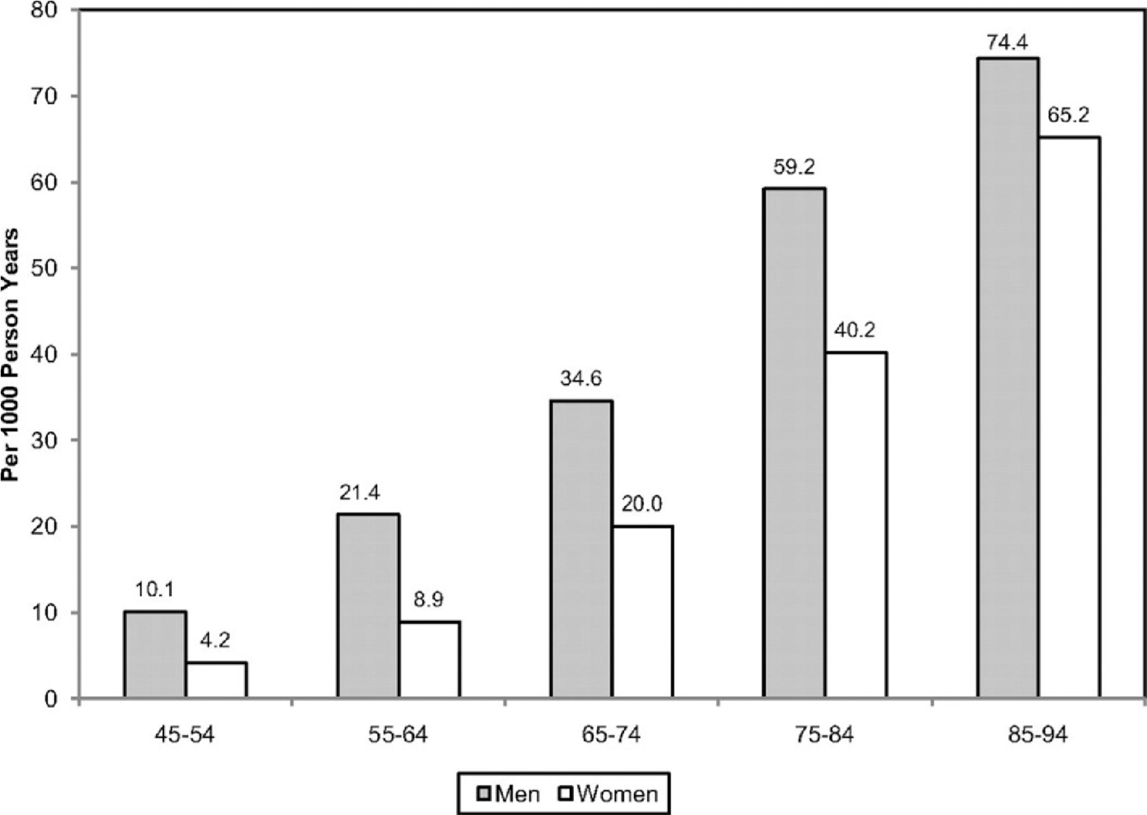

Figure 3 Annual number of adults having diagnosed heart attack or fatal coronary heart disease by age and sex.

As illustrated in Figure 3 the absolute number of annual CVD deaths among the female sex has exceeded that of the male sex since 1984. These data are often confused with CVD mortality rates, which, when adjusted for differences in age distribution, reveal that the CVD mortality rate is substantially higher in men than women. In 2007, the age-adjusted CVD death rate in men was 300 per 100 000 compared with 212 per 100 000 women. The 2007 CVD mortality rate in women represents a 43% reduction from the rate in 1997. From 1980 to 2000, the age-adjusted death rate for CHD fell from 263 to 134 per 100 000 women; during the same time period, the rate fell from 543 to 267 per 100 000 men.[70]

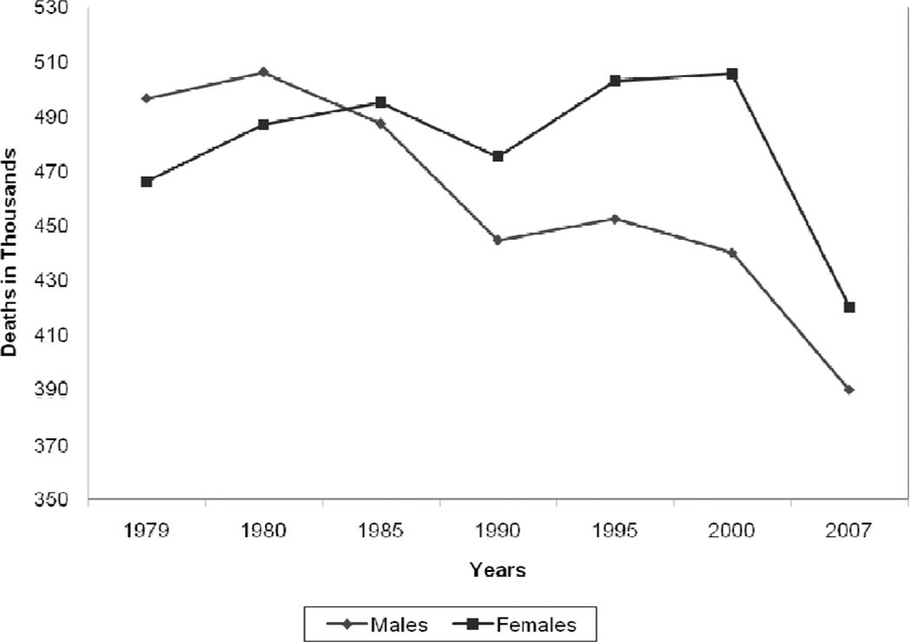

Figure 4 Trends in the total annual number of deaths caused by cardiovascular disease according to gender The prevalence of CVD in women varies according to racial/ethnic minority status. The prevalence of CVD among women ≥20 years of age is 47% among blacks, 34% among whites, and 31% among Mexican Americans; the prevalence of CHD is 7.6%, 5.8%, and

5.6%, respectively.[70] Asian women ≥18 years of age have the lowest prevalence of CHD (3.9%), according to the National Center for Health Statistics. The age-adjusted CHD death rate is highest among black women (122 per 100 000 compared with 94 per 100 000 in white women). The ominous trend for increasing rates of hypertension among black women is of particular concern because the increased risk for both CHD and stroke compared with white women could potentially widen the racial gap in CVD mortality. Dr Bernadine Healy first introduced the concept of the Yentl syndrome in 1991, suggesting gender bias in the management of CHD. There is ongoing debate as to whether women have a poorer prognosis after a myocardial infarction (MI) than men, and why. Is any observed difference explained by delay in women seeking care, healthcare provider delay in recognition and treatment, underlying differences in pathophysiology, more comorbidities, or older ages at time of presentation among women compared with men?[71]

Data over the past decade have shown that women have a higher 30-day mortality compared with men, and it is now recognized that the gender differences are largely explained by clinical differences at presentation. The higher mortality rate among women appears to be limited primarily to ST-segment–elevation MI. It has also been suggested that higher death rates may be restricted to younger women.[72] Although women with acute coronary syndromes may have similar benefits from antiplatelet pharmacotherapy as men, they are more likely to have bleeding problems, possibly as a result of excess dosing. Women experience greater morbidity and mortality than men after coronary artery bypass grafting; this disparity may reflect technical difficulties resulting from differences in body size, more microvascular disease, and different risk factor profiles. More recently, it has been shown that increasing use of off-pump coronary artery bypass grafting has narrowed the gender disparity in outcomes. Early studies that examined gender differences in outcomes after MI and revascularization may no longer be relevant owing to temporal trends in management and risk factor profiles.[73] Recent data from the National Registry of Myocardial Infarction showed that in-hospital mortality after an acute MI decreased more in women than in men between 1994 and 2006; the absolute reduction was 3 times larger in women than in men <55 years of age (2.7% versus 0.9%). This narrowing of the mortality gap was explained largely by greater improvements in risk factors in women than in men.[74] The classic risk factors for CVD are the same in women and men, but there are gender differences in the prevalence of risk factors. Although women and men overall have nearly equal percentages of hypertension (1 in 3 adults), data from the National Health and Nutrition Examination Survey (NHANES) showed that the prevalence of high blood pressure is greater in women >65 years of age. The highest rate of hypertension is among black women, 44%, and is increasing. The death rate caused by hypertension in 2007 was 37.0 per 100 000 for black women compared with 14.3 per 100 000 for white women. Diabetes mellitus is more prevalent among women than men ≥20 years of age (8.3% versus 7.2%).[75] Type II diabetes mellitus imparts a greater risk of CHD in women than men and is not explained by differences in risk factors, but rather by the more favorable survival rate of women (than men) without diabetes mellitus. The prevalence of physician-diagnosed diabetes mellitus is highest among non-Hispanic black (14.7%) and Mexican American (12.7%) women. On the basis of the NHANES data, the age-adjusted prevalence of the metabolic syndrome is highest among Mexican American women (40.6%), which is ≈22% higher than in Mexican American men. The prevalence of total cholesterol ≥240 mg/dL in 2008 for those ≥20 years of age was 16.2% among women and 13.5% among men. In contrast, the percent of women with high-density lipoprotein cholesterol <40 mg/dL was 9.7% compared with 29.5% among men.[76]

Lifestyle risk factors also vary by gender, race, and ethnicity. Cigarette smoking has decreased overall in the United States, but remains more common among men than women (23.1% versus 18.1%). Non-Hispanic white women have a higher rate of smoking (20.7%) than black women (18.8%) and Hispanic women (9.4%). Age-adjusted rates of physical inactivity in 2009 were higher in women than men (34.5% versus 30.3%). Adverse trends in levels of physical activity (> 12 times a month) reveal a decline from 1988 to 2006 from 57% to 43% in men and from 49% to 43% in women.[77] The decreasing levels of physical activity parallel the rising rates of overweight and obesity in the United States. Two thirds of Americans are overweight or obese (72% of men and 64% of women) as defined by body mass index. Among women, non-Hispanic blacks and Mexican Americans are more likely to be obese than non-Hispanic whites (50% versus 45% versus 33%, respectively).[78] From 1999 to 2008, the increase in the prevalence of obesity was greater among men than women.[79] Full adherence to 3 heart-healthy lifestyle behaviors (smoking abstinence, physical activity, and fruit and vegetable intake) was nearly 50% higher among women than men without CHD in a 2000 sample of the US population. Overall adherence was low (<20%) for both women and men. These data suggest that population-wide approaches are needed to reduce the burden of CVD in both genders.[80]

**Closing the Gap in Preventive Care**

Adherence to guidelines for the prevention of CVD is suboptimal for women and men. The extent to which physician behaviors, patient behaviors, and environmental factors explain nonadherence is not established.[81] The limited systematic evaluation of provider performance in CVD preventive care makes it difficult to document gender differences in the delivery of care. Etiologic explanations for any observed gender differences in adherence to preventive recommendations are even more elusive. Most studies are conducted in select settings, use a variety of quality indicators, and report limited data on confounding or effectmodifying variables. Despite these research limitations, several themes consistently emerge regarding barriers to optimal preventive care. A fundamental barrier to implementation of prevention guidelines may be the guidelines themselves. Shaneyfelt et al evaluated the guidelines process and found that longer guidelines included more standards than shorter guidelines but were more often ignored in practice.[82] Evidence-based recommendations were used more often than recommendations for practice not based on research evidence, and controversial recommendations were followed less often than those that were noncontroversial. A study of AHA/American College of Cardiology Guidelines showed that adherence was higher when the recommendations were supported by randomized, controlled clinical trials. Guidelines are more likely to be followed if they are easy to implement and come from a highly respected source.[83] The AHA has published 3 women-specific evidence-based guidelines between 2004 and 2011 for the prevention of CVD, but the extent to which these guidelines changed physician behavior or affected any gender gap in risk factor management is not known. The most recent AHA women’s guideline 2011 update emphasized the importance of risk assessment to improve the quality of preventive care and highlighted challenges of available risk assessment tools: short-term focus, relevance of outcome measures (CVD versus CHD), and underestimation of risk in women. Further research is needed to determine whether improved risk assessment is associated with improved clinical outcomes.[84] Cabana et al evaluated 76 studies describing barriers to adherence to clinical practice guidelines; lack of awareness, lack of familiarity, lack of agreement, lack of self-efficacy, lack of outcome expectancy, and inertia of previous practice were recurring thematic barriers for following guidelines. It was suggested that AHA guidelines for the prevention of CVD in women are heterogeneous, and consequently there are different barriers to implementation of individual recommendations.[85] In a national AHA study of 500 randomly selected physicians, the most commonly cited barriers to implementation of CVD prevention guidelines were time, insurance coverage, and the patient. This study also revealed that physician assessment of CVD risk of the patient was the primary driver of quality preventive care. Gender disparities in treatment were explained largely by the provider’s lower perceived CVD risk in women, despite a similar calculated risk compared with men. A subanalysis of this study suggested that solo practitioners and older physicians should be targeted to help promote the use of the guidelines. In a program designed to improve screening and management of CHD risk factors in women, internists and obstetricians/gynecologists were queried about barriers to primary prevention; physician time was perceived as a major barrier to the provision of preventive care.[86] The authors suggest that the current structure and reimbursement system for health care must be addressed if the gender gap in CVD preventive care is to be reduced. In a nationally representative sample of women, the most frequently cited barriers to heart health were confusion in the media (49%), the belief that health is determined by a higher power (44%), and caretaking responsibilities

(36%). Psychosocial factors may also contribute to nonadherence to preventive recommendations in women. For example, depression and social isolation have been linked to CVD risk and may be mediated by nonadherence to preventive recommendations, although there is a lack of clinical trials to document that treatment of psychosocial risk improves patient outcomes. The roles of body image and other psychological, social, and cultural factors as mediators of nonadherence deserve further study. Systems approaches to CVD prevention have the potential to improve outcomes and to reduce disparities. The Get With the Guidelines Quality Improvement Program has shown improved adherence to secondary prevention guidelines over time for both women and men, but the data are subject to selection bias and secular trends.[87]

***The association between blood pressure and mortality in patients with heart failure.***

Blood pressure is the force that pumps blood around the circulatory system. When blood flow is restricted or blocked completely, the heart muscle is starved of oxygen. This leads to a heart attack. During a heart attack, blood pressure can go up, down, or remain constant, depending on how the body responds.[88]

Increase in blood pressure - Blood pressure might rise during a heart attack because hormones, such as adrenaline, are released. These hormones are released when the "fight or flight" response is triggered at times of intense stress or danger. This automatic response might make the heart beat faster and stronger.[89]

Decrease in blood pressure - Blood pressure might drop if someone is having a heart attack because the heart is too weak to maintain it, as the muscle might have been damaged. The severe pain a person might feel during a heart attack could also trigger an automatic response, which might lead to decreased blood pressure and fainting.[90]

Blood pressure and heart attacks - If high blood pressure is left untreated, it could increase the risk of a heart attack. High blood pressure can be a measure of how hard the heart is having to work to pump blood around the body via the arteries, which is why doctors monitor it. A buildup of fat, cholesterol, and other substances within the arteries is called plaque. Over time, plaque hardens, causing the arteries to narrow. This narrowing means it takes more pressure to push the blood through the network of tubes. When plaque breaks away from the wall of an artery, a blood clot is formed around the plaque. Heart attacks can happen because plaque or blood clots cause the blood supply to the heart to be disrupted or blocked. High blood pressure is not always a severe health problem, however. Even healthy people can experience raised blood pressure from time to time due to exercise or stress.[91] How is blood pressure measured?

1. Systolic blood pressure (SBP) is the pressure in the arteries, as the heart pumps blood out to the body.
2. Diastolic blood pressure (DBP) is the pressure in the arteries between heart beats.

On blood pressure charts, the top number refers to the systolic pressure, while the number underneath refers to the diastolic pressure.

The association between low blood pressure and prognosis in the general population has been controversial, with some reports suggesting an increased mortality for patients with the lowest blood pressures. Whereas many standard heart failure therapies decrease blood pressure, the relationship between mortality and blood pressure in patients with heart failure has not been previously evaluated. We used the Digitalis Investigation Group trial database to evaluate retrospectively the relationship among systolic blood pressure (SBP), diastolic blood pressure (DBP), and survival among 5747 patients with New York Heart Association class II or III heart failure and left ventricular ejection fraction < or = 0.45. Cox proportional hazards models were used to identify covariates predictive of long-term mortality.[92]

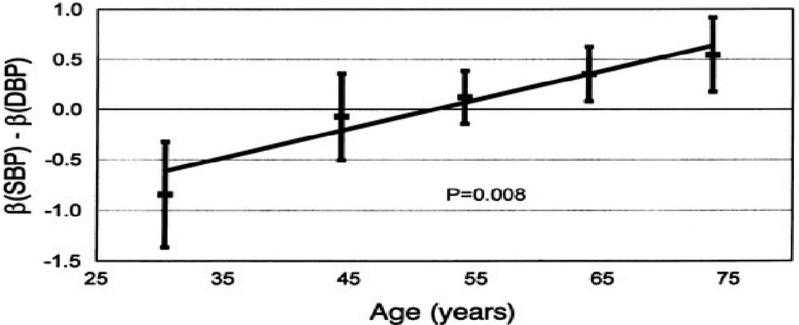

Figure 5 SBP and DBP wrt to Cardiovascular Disease Presence

RESULTS: The adjusted all-cause mortality rate during the entire study period for patients in the lowest SBP group (< 100 mm Hg) was 50% and was significantly higher than that of the reference group of patients with SBP of 130 to 139 mm Hg, which had a mortality rate of 32% (hazard ratio 1.65, 95% CI 1.25-2.17, P < .001). The relationship between SBP and mortality was significant (P < .001) and nonlinear (P = .009). The relationship between DBP and mortality was significant (P < .001), with the highest mortality seen in patients with DBP < 60 mm Hg. In patients with systolic dysfunction (left ventricular ejection fraction < or = 0.45) and New York Heart Association classes II and III symptoms, lower SBPs and DBPs were associated with greater mortality.[93]

***Chest Pain and its risk factor to Cardiac arrest***

Angina is chest pain or discomfort caused when your heart muscle doesn't get enough oxygenrich blood. It may feel like pressure or squeezing in your chest. It is a symptom of an underlying heart problem, usually coronary heart disease (CHD).There are many types of angina, including microvascular angina, Prinzmetal's angina, stable angina, unstable angina and variant angina. This usually happens because one or more of the coronary arteries is narrowed or blocked, also called ischemia. Angina can also be a symptom of coronary microvascular disease (MVD). This is heart disease that affects the heart’s smallest coronary arteries and is more likely to affect women than men. Coronary MVD also is called cardiac syndrome X and non-obstructive CHD. Learn more about angina in women.[94]

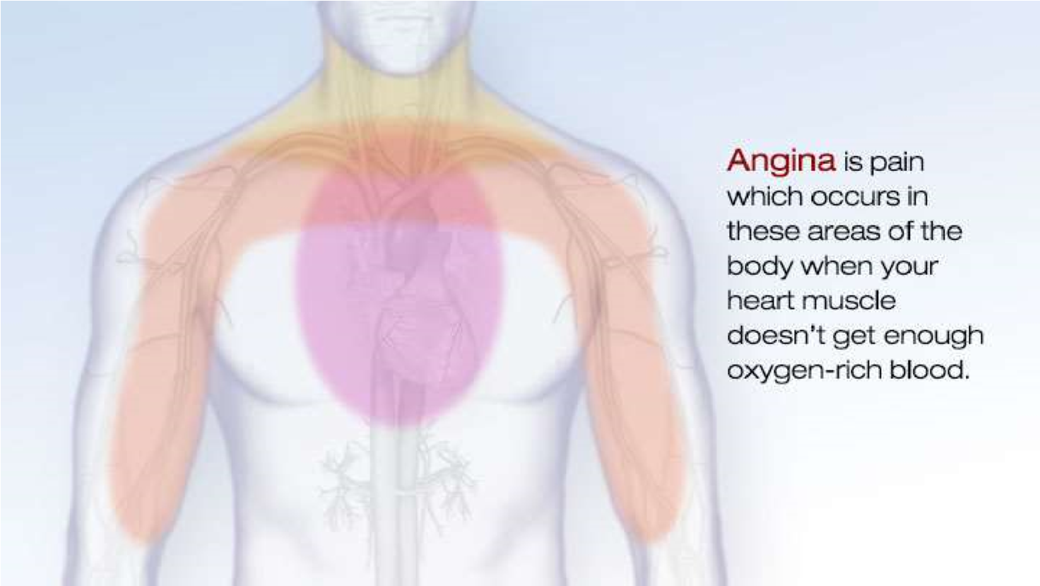

Figure 6 Pain Areas to be concerned about when having an Angina (Chest Pain)

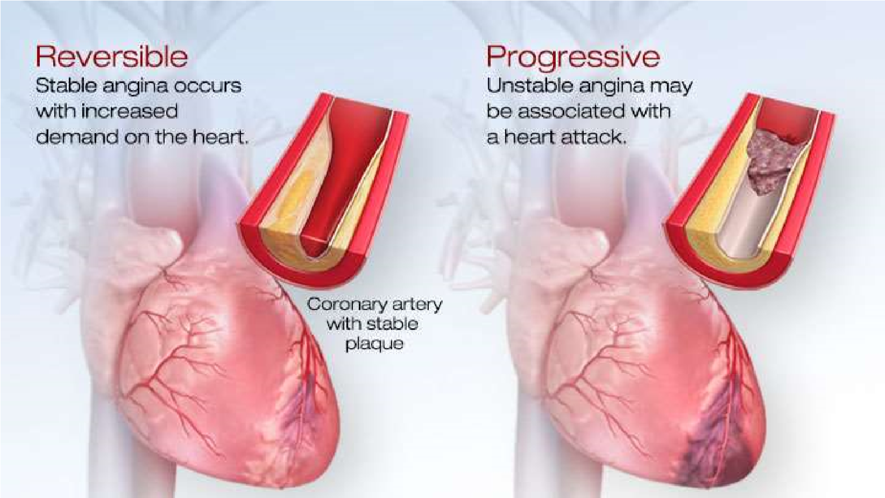

Figure 7 Reversible and Progressive Angina

Types of Angina - Knowing the types of angina and how they differ is important.

* Stable Angina / Angina Pectoris
* Unstable Angina
* Variant (Prinzmetal) Angina
* Microvascular Angina

Diagnosis of Angina - All chest pain should be checked out by a healthcare provider. If you have chest pain, your doctor will want to find out whether it's angina and if it is, whether the angina is stable or unstable. If it's unstable, you may need emergency medical treatment to try to prevent a heart attack.

Your doctor will most likely perform a physical exam, ask about your symptoms, and ask about your risk factors for and your family history of heart disease and other cardiovascular conditions.

1.5.5 Cholesterol and Heart Disease

Cholesterol helps your body build new cells, insulate nerves, and produce hormones. Normally, the liver makes all the cholesterol the body needs. But cholesterol also enters your body from food, such as animal-based foods like milk, eggs, and meat. Too much cholesterol in your body is a risk factor for heart disease.[91]

**How Does High Cholesterol Cause Heart Disease?**

When there is too much cholesterol in your blood, it builds up in the walls of your arteries, causing a process called atherosclerosis, a form of heart disease. The arteries become narrowed and blood flow to the heart muscle is slowed down or blocked. The blood carries oxygen to the heart, and if not enough blood and oxygen reach your heart, you may suffer chest pain. If the blood supply to a portion of the heart is completely cut off by a blockage, the result is a heart attack. There are two forms of cholesterol that many people are familiar with: Low-density lipoprotein (LDL or "bad" cholesterol) and high-density lipoprotein (HDL or "good" cholesterol.) These are the form in which cholesterol travels in the blood. LDL is the main source of artery-clogging plaque. HDL actually works to clear cholesterol from the blood. Triglycerides are another fat in our bloodstream. Research is now showing that high levels of triglycerides may also be linked to heart disease.[95] What Are the Symptoms of High Cholesterol?

High cholesterol itself does not cause any symptoms, so many people are unaware that their cholesterol levels are too high. Therefore, it is important to find out what your cholesterol numbers are. Lowering cholesterol levels that are too high lessens the risk for developing heart disease and reduces the chance of a heart attack or dying of heart disease, even if you already have it.[96]

**Do I need Treatment For High Cholesterol?**

Many health care providers recommend treating anyone with CVD with high-dose statin therapy. This includes those with coronary heart disease and who have had a stroke. For those who do not have CVD, treatment is determined by your individual risk for developing heart disease. That risk can be estimated using calculators which factor your age, sex, medical history, and other characteristics. If your risk is high (such as a 7.5 or 10 percent risk of developing CVD over 10 years), your doctor may start you on treatment preventively. They generally keep in mind your preferences towards taking medication in general. For those people whose risk is unclear, a coronary artery calcium score, which is a screening test looking for calcium (an indication of atherosclerosis) in the arteries, can help determine the need for statins. For both those who have CVD and those who do not, when the decision is made to start medication, the first choice is usually a statin.[97] Other special groups who may need treatment:

* People with high triglyceride levels may benefit if they have other risk factors
* People with diabetes: are at high risk, and a ldl under 100 is recommended for most
* Older adults: a healthy, active older adult may benefit reduction you need, and prescribe a medication accordingly.

1.5.6 Fasting Glucose Level or Fasting Blood Sugar and the Risk of Heart Diseases

Both low glucose level and impaired fasting glucose should be considered as predictors of risk for stroke and coronary heart disease. The fasting glucose level associated with the lowest cardiovascular risk may be in a narrow range.[98] Diabetes is a well-established risk factor for cardiovascular disease (CVD) and all-cause mortality. Impaired fasting glucose (IFG), defined by the American Diabetes Association as having a fasting plasma glucose level of 100–125 mg/dL (5.6–7.0 mmol/L) or a 2-h value on the oral glucose tolerance test of 140–199 mg/dL (7.8–11.1 mmol/L) was associated with CVD risk in several studies.[99] The evidence is inconsistent, however, and the clinical relevance of IFG as a predictor of CVD is still unclear. In addition, the shape of the dose-response relationship between CVD risk and fasting glucose level has not been well characterized across the full range of fasting blood glucose values. It is unclear whether there is an optimum fasting glucose level associated with the lowest level of CVD risk, or whether risk increases at very low fasting glucose levels.[95] Several studies have shown J-shape or U-shape relationships between fasting glucose levels and mortality. The Cancer Prevention Study (CPS) is a cohort study of >1.3 million adults designed to evaluate major risk factors for chronic diseases and mortality. The large sample size of this cohort facilitated detailed characterization of the dose-response relationship of fasting glucose level with the incidence of clinical CVD end points. In a large cohort of men and women, we found that fasting glucose level was associated with higher risk for major CVD outcomes, increasing from a level of ∼90 mg/dL after controlling for other risk factors.[100] The dose-response curves showed progressive increments in the HRs from this value at both higher and lower levels; the increased risk was greatest for stroke. The patterns of association were similar in men and women, but the associations were stronger in women. Substantial evidence supports the biological plausibility of this finding. Experimental studies show that abnormal glucose metabolism impairs normal endothelial function, accelerates atherosclerotic plaque formation, and contributes to plaque rupture and thrombosis.[101] Epidemiological studies provide complementary evidence. In the Rotterdam Study, among elderly participants with a fasting blood glucose <110 mg/dL and without diabetes, those with higher blood glucose levels had higher levels of arterial stiffness.

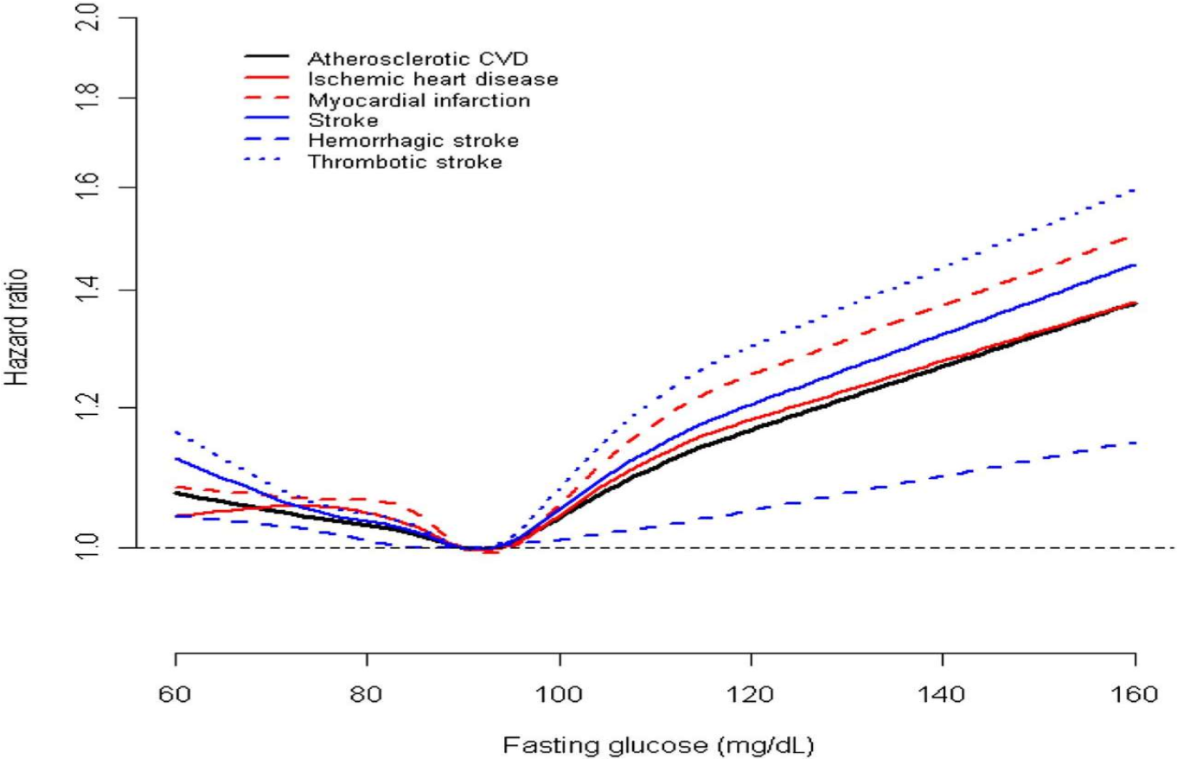

Figure 8 FBS analysis for Men

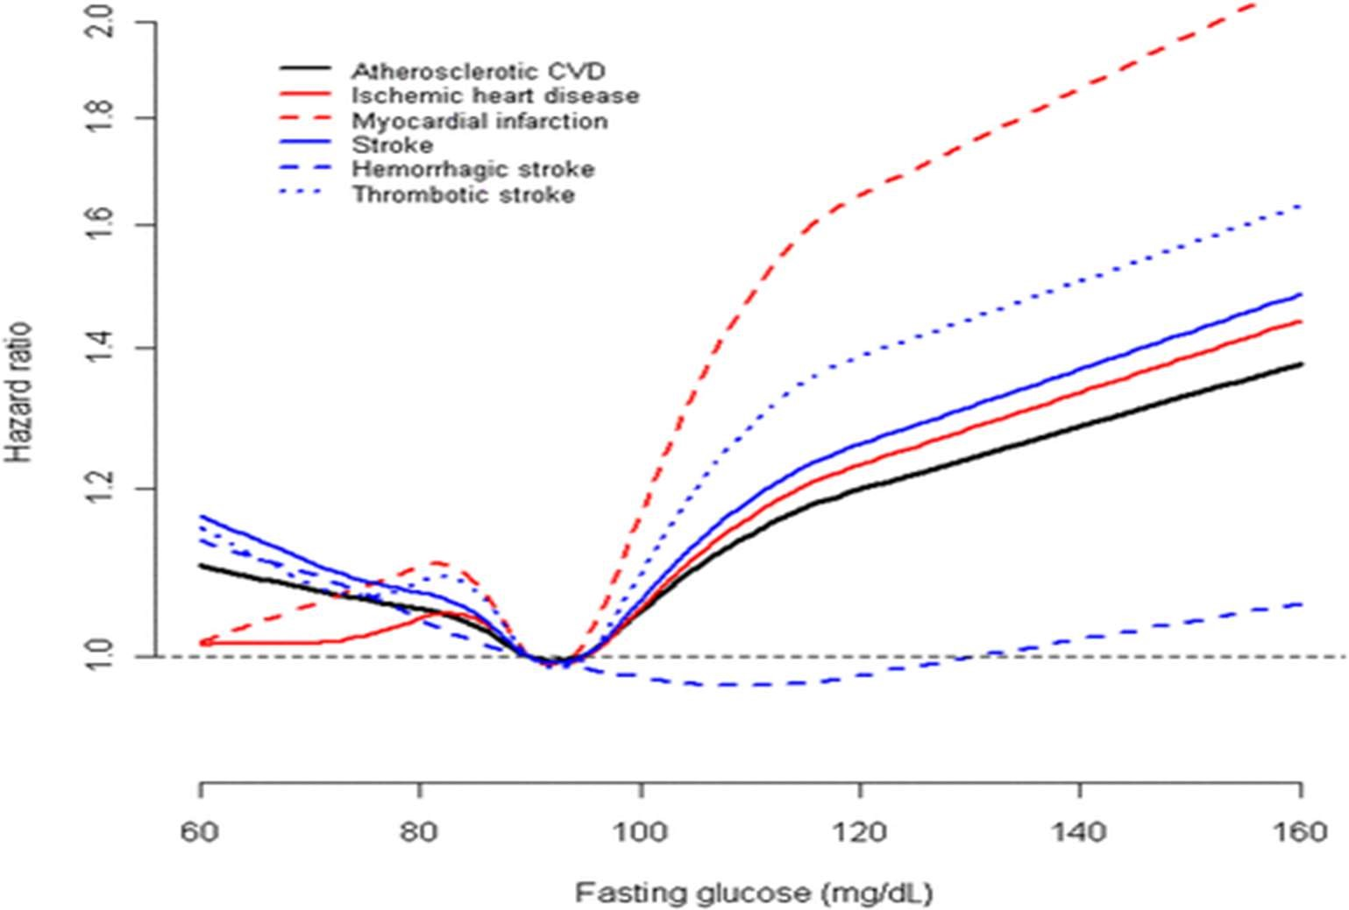

Figure 9 FBS analysis for Women

CATHAY study found that higher levels of glycemia (102–124 mg/dL) were associated with arterial endothelial dysfunction and intima-media thickening. In a biomarker study in Italy, a number of CVD biomarkers showed positive dose-response relationships with fasting glucose across three strata: <100; 100–109; and 110–125 mg/dL. Our study adds to the increasing evidence that IFG is an independent risk factor for incident CVD, including ischemic heart disease and stroke. In addition, the effects of other CVD risk factors may be enhanced by abnormal glucose metabolism.[102][103]

1.5.7 Electrocardiograph (ECG) Test for Heart Diseases

An electrocardiograph is the most common test for heart conditions. An electrocardiograph machine records your heart's rhythm onto paper through sticky electrodes which are placed on your chest, arms and legs. The recording will show if the heart muscle is damaged or short of oxygen. Specialized ECG tests:

* An exercise tolerance test (ETT) involves two ECG scans, one when you are exercising and one when you are resting. Some heart problems only appear when your heart needs to work harder. This test helps to show how your heart copes under stress.[104]
* A cardiac Holter monitoring test is used to identify any heart rhythm problems. For this test you wear a small, portable ECG machine for 24 or 48 hours and during this time your heart rate and rhythm are recorded.[105]
* Event monitoring is used to record your heartbeat when you experience symptoms such as dizziness, black outs, chest pain or palpitations. When you experience symptoms, you will need to press a button to start the recording.[106]

***Cardiac Complications in Thalassemia Major***

Thalassemia major is characterized by chronic ineffective erythropoiesis and anemia as its primary problems. These, in turn, produce physiologic adaptations in the cardiovascular system as well as pathologic/iatrogenic processes such as iron overload, splenectomy, nutritional deficiencies, chronic oxidative stress, and lung disease. This article discusses the pathophysiology of thalassemia as it relates to the cardiovascular system, the mechanisms and monitoring of iron cardiomyopathy, pulmonary hypertension, and vascular aging in thalassemia patients.[107]

1. Chronic Anemia - Patients with chronic anemia increase their cardiac output to maintain oxygen delivery, resulting in increased cardiac dimensions and heart rate. Anemic patients have larger hearts on CXR, echo, and MRI measurements than patients with normal hemoglobin levels, even without any other pathology. Thus, normative data generated from non-anemic patients is inappropriate for patients with hemoglobinopathies.[108] The larger cardiac dimensions, stroke volumes, and heart rates carry metabolic cost; chronically anemic patients have higher resting oxygen consumption and decreased reserves. Increased resting metabolism is also a source of increased oxidative stress, independent of the free-radical effects of iron. Patients with thalassemia have low or normal blood pressures, despite their increased cardiac output, because they have lower vascular resistance. Lower tonic vascular tone partially compensates for the increased chamber dimensions, but it leaves patients vulnerable to the endothelial toxicity of iron overload as well as making them less tolerant and responsive to the effects of afterload-reducing agents.
2. Splenectomy - Hypersplenism is relatively common in the thalassemia’s and may necessitate spleen removal. Splenectomy may also be performed to lower blood transfusion requirements. However, the spleen plays a critically important role in removing hematologic debris from the cardiovascular system. Phosphatidylserine positive platelets, platelet fragments, and red cell fragments are powerful procoagulants. They also inhibit nitric oxide, stimulate vasoconstricting substances such as endothelin and vasoconstricting prostaglandins, and produce endothelial proliferation[109]. The spleen also removes brittle senescent red cells from the circulation, suppressing intravascular hemolysis. Cell-free hemoglobin is a powerful oxidant and scavenger of nitric oxide. As a result, splenectomy is a strong risk factor for intravascular thrombosis and pulmonary hypertension.
3. Iron Overload - Patients with thalassemia develop iron overload through increased iron absorption and trans fusional therapy. Iron is toxic to all the endocrine glands that support the heart. Insulin-resistance and frank diabetes are relatively common. Hyperglycemia and insulin resistance are powerful oxidative stressors to the heart, worsening the effects of iron overload. Proper insulin sensitivity is also vital for efficient cardiac energy utilization. Iron may also poison the thyroid and parathyroid gland, impairing metabolism and calcium regulation respectively. Iron-mediated adrenal insufficiency may also manifest itself during metabolic stress. Deficiencies of growth hormone and the sex steroids impair cardiac function. Iron-mediated endocrine toxicity must be excluded in TM patients with cardiac failure.[110]
4. Nutritional Deficiencies - The hemoglobinopathies are a hypermetabolic state and inherently produce chronic oxidative stress. Broad-spectrum nutritional deficiencies are prevalent and may reinforce disease toxicity. Fat-soluble vitamin depletion is common, including vitamin A, D, E, and K, suggesting fat mal-absorption. The mechanisms and consequences are unknown. Vitamin D deficiency is associated with increased cardiac iron and decreased function, but causation has not been proven. Many trace metals are decreased, including selenium, zinc, and copper. B-vitamin levels are also low, particularly thiamine, riboflavin, and folate, most likely from consumption during ineffective erythropoiesis. Severe thiamine deficiency can have neurological and cardiac toxicity, whereas deficient riboflavin and folate may result in elevated homocysteine and endothelial toxicity. Carnitine deficiency is also relatively common in thalassemia and can impair cardiac function.[111]

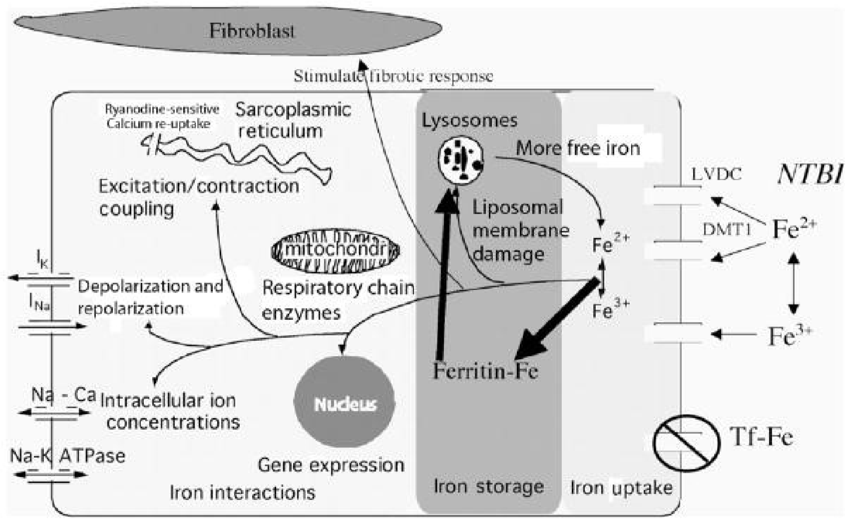

Figure 10 Iron Cardiomyopathy - represents the pathophysiology of iron cardiomyopathy, artificially divided into iron uptake, iron storage, and iron toxicity. The heart takes up physiologic

amounts of iron through transferrin receptors, but this process is tightly regulated and does not lead to

iron overload. When transferrin-binding capacity is exceeded, circulating low molecular weight nontransferrin-bound iron (NTBI) species appear. NTBI is oxidatively active and can enter through

nonspecific, poor-regulated cation channels in the heart, leading to cardiac iron overload. Several

channel mechanisms have been proposed, including L-type voltage-dependent calcium channels, but much more work is necessary to characterize cardiac iron-uptake processes.

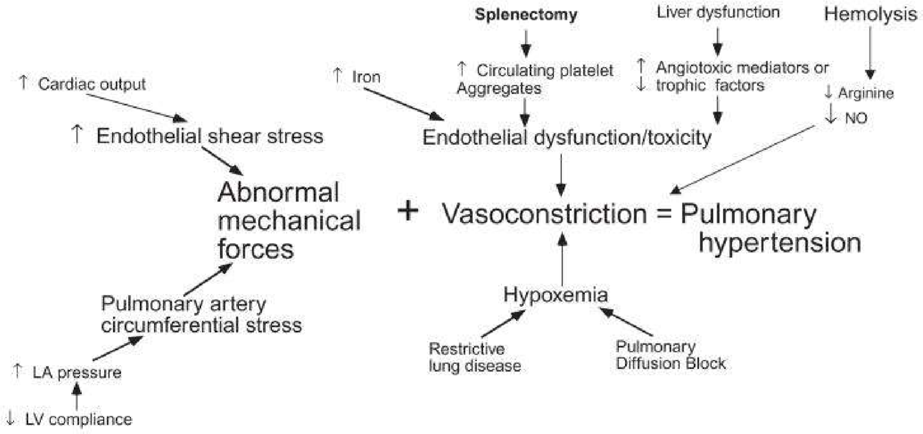

Figure 11 Pulmonary Hypertension - demonstrates the complex pathophysiology of pulmonary hypertension in thalassemia. Increased cardiac output and diastolic dysfunction cause abnormal loading of the pulmonary artery. Lung disease can exacerbate night-time hypoxia, a powerful stimulus for vasoconstriction. Iron, phosphatidylserine-expressing hematologic debris, free hemoglobin, and other circulating angiotrophic factors cause vasoconstriction and intimal proliferation.